- 整个文档页边距：
上2下2；左3右2cm
页脚边距：1.1

- 正文部分（参照正文格式）
中文除标题有特别规定外均用宋体，英文用Times New Roman体。正文段落用1.3倍行间距，段前段后均0磅。
定稿后请删除所有文本框！



本科生毕业设计（论文）外文资料译文

（ 2024届）
四号楷体，短题目居中，超过一行的长题目手动换行，均居左。请不要改变字体字号。题目确保与系统内的一致

论文题目 | 基于手机系统的宠物信息交流平台微信小程序的设计与实现
小四号楷体，居中

学生姓名 | 张子轩 | 学号 | 2022210402023
专业 | 计算机科学与技术 | 班级 | 计算机224
指导教师 | 陈立东 | 职称 | 讲师
班级名称：
班级名：
计算机201
计算机202
计算机203
计算机204
计算机205
计算机206
软工201
软工202
物联网201
计算机2208
计算机2209
计算机2210

专业名称写全称
计算机科学与技术（师范）
计算机科学与技术（金融信息服务）
计算机科学与技术
软件工程
物联网工程
地理信息科学
计算机科学与技术（专升本）
PS:若名称过长可适当缩小字号调整到同一行

信息科学与技术学院

外文资料译文规范说明
一、译文文本要求
1．外文译文不少于3000汉字；
2．外文译文本文格式参照论文正文规范（标题、字体、字号、图表、原文信息等）；
3．外文原文资料信息列文末，对应于论文正文的参考文献部分，标题用“外文原文资料信息”，内容包括：
1）外文原文作者；
2）书名或论文题目；
3）外文原文来源：
□出版社或刊物名称、出版时间或刊号、译文部分所在页码
□网页地址
二、外文原文资料（电子文本或数字化后的图片）：
1．外文原文不少于10000印刷字符（图表等除外）；
2．外文原文若是纸质的请数字化（图片）后粘贴于译文后的原文资料处，但装订时请用纸质原文复印件附于译文后。
整页替换：
导师意见从系统导出，然后替换本页。

指导教师意见：

指导教师签名： 年 月 日

一、外文资料译文：

基于 Redis 的高性能分布式缓存架构研究
关键词：Redis，缓存，高性能，分布式

缓存系统现状与问题
随着云计算的普及和企业级应用规模的扩大，系统对请求吞吐量的要求不断提高。当并发请求达到一定阈值后，单纯缩短数据库访问时间已无法满足业务需求，甚至可能导致系统响应缓慢或整体瘫痪。在此背景下，高性能缓存系统应运而生。在以往的实践中，缓存的实现形式通常包括以下几种：Map 或 Table、内存缓存、单点缓存。
上述缓存方式各自具有优点和缺点：
（1）Map 或 Table 具有访问速度快的优点，但内部不支持缓存条目的过期功能，因此仅适用于存储少量且无需设置过期时间的数据，在面对海量数据时将会遇到诸多问题；
（2）Oscache 和 Ehcache 是较为成熟的内存缓存，但当数据量较大时会大量占用服务器内存，从而可能影响正常业务功能，同时也不适用于多服务器之间共享缓存条目；
（3）Memcache 提供了高效的文本访问协议，并允许多台服务器共享缓存内容，但其自身不提供集群、热备和持久化功能，一旦发生单点故障，所有数据将全部丢失，而这种损失在大多数业务场景中是不可接受的。

分布式缓存解决方案

Redis
Redis 是一种具有卓越性能的 NoSQL 数据库。与 Memcache 类似，它实现了一种轻量且便捷的通信协议，用于支持简单访问。同时，它还支持比 Memcache 更多的数据类型，包括链表、集合以及有序集合等复杂类型。因此，可以实现数据的批量插入、修改和删除操作，而这些操作都是原子性的，在非键值型缓存操作场景中具有重要意义。
由于 Redis 是内存数据库，其天然具备持久化机制。它可以定期将内存中的数据写入磁盘，或将修改操作写入补充日志文件。通过这种方式，Redis 在宕机情况下不会丢失数据，并且可以快速将最近一次快照的数据从磁盘加载到内存中。
此外，与大多数基于客户端实现的分布式缓存不同，Redis 基于持久化机制实现了服务器之间的主从同步，即实现了一种基于服务器端的分布式缓存系统。由此降低了客户端的压力，同时也避免了由于客户端不稳定而导致主从服务器之间的数据不一致问题。

分布式缓存
单点部署的缓存系统虽然易于保证数据一致性，但一旦发生宕机，将对主系统造成灾难性后果。因此，有必要在多个位置部署缓存并相互进行备份，这就是所谓的分布式缓存。当某个缓存发生故障时，可以手动或自动地将主系统对缓存的访问切换到备份缓存上，从而确保主系统的正常稳定运行。
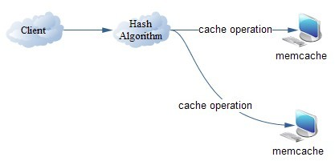
图 1
如图 1 所示，目前广泛使用的分布式缓存主要是基于 Memcache 实现的。Memcache 分布式缓存的优点包括：自定义通信协议、访问速度快以及支持多种客户端。从图 1 可以看出，Memcache 分布式缓存的缺点在于：
- 分布式实现过度依赖客户端；
- 涉及数据添加和删除的操作需要通过客户端同步发送至所有服务器。
因此，这会给客户端带来一定压力，并且一旦发送过程中发生错误，所有缓存服务器中的数据将变得不一致。此外，Memcache 无法实现数据的持久化，一旦缓存服务器发生故障，数据将全部丢失，从而无法保证数据的一致性。

架构设计

架构改进
为改进上述架构的不足，结合 Redis 优秀的持久化功能，本文设计了如下所示的分布式缓存架构。
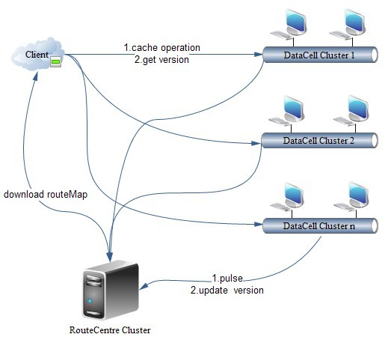
图 2
该架构包含三个主要角色：Client、RouteCentre 和 DataCell。
Client 在启动时从 RouteCentre 集群获取可用的 DataCell 路由表，然后根据路由表、初始化的连接池以及 Key 的哈希值访问对应集群中的 DataCell。当且仅当从 DataCell 获取到的版本号高于 Client 当前持有的版本号时，Client 才会重新从 RouteCentre 集群获取最新可用的 DataCell 路由表。
RouteCentre 除了为 Client 提供路由表下载功能外，还可以接收来自 DataCell 的心跳请求，用于重新更新 DataCell 的状态和路由表，并将最新版本号反馈给 DataCell。
DataCell 为 Client 提供相关的缓存操作接口及当前版本号，同时向 RouteCentre 发送心跳并更新当前最新版本。DataCell 基于 Redis 实现，并结合 RouteCentre 的控制阶段，实现了较高的鲁棒性和可扩展性。

数据流
频繁访问数据库会带来较高的系统开销，或者其他外部资源接口的质量具有不确定性。基于此，为了追求更快的访问速度和更高的吞吐率，系统需要屏蔽底层外部接口之间的速度差异，并实现接口访问速度的一致性。
在该需求下，请求在 Client 端被抽象为 Key，对应外部接口返回的数据被作为 Value，二者共同缓存于 DataCell 中，记为 D1。通过 Redis 的同步机制，与 D1 组成集群的 D2 会自动插入相同的 Key 和 Value，并保持与 D1 的数据一致性。
在数据有效性方面，当新请求与原请求相同（即请求的 Key 相同）时，请求将通过 Client 端的哈希算法随机转发至 D1 或 D2。当其中一个节点发生故障时，Client 可以智能地将请求转发至同一集群中无故障的 DataCell。随后，对应 Key 的结果将返回给 Client 调用。
因此，在命中缓存的情况下，可以避免与数据库或外部接口的交互，从而显著提升接口访问速度。

特性实现
缓存系统实现了以下特性：
- 具备足够的鲁棒性，当单个 DataCell 宕机时，系统能够自动切换至对应的备用节点，而不会影响 Client 对缓存的正常访问；
- DataCell 集群具备良好的扩展性，当单个 DataCell 出现性能瓶颈时，可通过扩展 DataCell 数量迅速分担主系统压力；
- DataCell 具备良好的分布特性，可灵活部署在不同虚拟位置或物理位置，并可通过心跳机制自动注册到 RouteCentre，从而快速、便捷地建立集群，为系统的鲁棒性和可扩展性提供了实践基础。

性能分析
在基于 Redis 的分布式缓存模型原型实现完成后，将其与基于 Memcachedb 的原始模型在相同测试环境下进行了对比。测试环境如下：操作系统为 Red Hat Linux Enterprise 5.5；CPU 为四核 2.5G；内存为 8G；Redis 版本为 2.02；Redis 作为内存数据库；Memcache 版本为 2.4；Barkley DB 作为内存数据库。
在 5 线程环境下，每个线程分别对 1K 的测试数据执行 10000 次读操作和 10000 次写操作，统计总操作时间进行对比，结果如表所示。
 | Read(ms) | Write(ms)
Memcachedb | 50360 | 56828
Optimized architecture based on redis | 22570 | 33498
由上表可见，基于 Redis 的优化架构在读写性能方面均优于 Memcachedb，但单次读取操作的耗时短于写入操作，更适用于“写少读多”的缓存场景。

结论与展望
通过对主系统中原有缓存系统的研究与改进（即基于 Redis 的分布式缓存架构应用），不仅显著提升了对高消耗主系统及高重复性外部接口的访问速度，同时也保证了缓存访问的高并发性和稳定性。因此，在发生单点故障时，主系统的正常运行仍可得到保障。
此外，Redis 采用操作系统的 dump 方式实现数据持久化，当数据量巨大而内存较小时，将产生性能瓶颈。因此，在该方面该架构仍具有一定的优化空间。

参考文献
[1] Xin Zhu, XiuLei Qin, LianHua Wang. Study on Elastically Distributed Cache Dynamic
Extension [J]. Computer Science and Exploration, 2011, 98-108.
[2] Design and Implementation of Web System Multilevel Distributed Cache Mechanism [J].
Modern library and information technology, 2011, 21-25.
[3] Bingcheng Liu. Deep Discussion on the Application of Ehcache System in Integration
Environment [EB/OL]. 2010. www.ibm.com.
[4] Chen Dan, Lin Zhao. TAOBAO Database Structure Evolution Course [EB/OL]. 2010,
www.slideshare.net/zhaolinjnu.
[5] Wenxiao Li, XiaoHu Yang. Message Oriented Middleware Storage Model Based on Distributed
Cache [J]. Computer Engineering, 2010, 93-95.
[6] Chiu D, Agrawal G. Flexible Caches for Derived Scientific Data over Cloud Environments
[R].The Ohio State University, 2009.
[7] Jure P. Using Memcache for Data Distribution in Industrial Environment [C]. Proc. of the 3rd
International Conference on Systems, 2008, 368-372.

外文原文资料信息
- 外文原文作者： Yadong Guo
- 外文原文所在书名或论文题目：Study on High-performance Distributed Cache Architecture based on Redis
- 外文原文来源：2012 2nd International Conference on Advanced Materials and Information Technology Processing(AMITP 2012)
出版社或刊物名称、出版时间或刊号、译文部分所在页码：2012-10-17
网页地址：https://kns.cnki.net/kcms2/article/abstract?v=lqoStndJ5wFccY34nSK5WQePzy2c6LqaK6FR_77fCFSLEtZ8NZfU2yQgVwk0FNBzrNYfIqKmeHDPygc-8VbC4lVj8-7-WyeBdJqxlto9EBZjZwMDejwqqpGlqokFPJbct4zi2ZbKNxizH1IE3z3QoGREhPny4Xho5-op-zTagUbswyVan7BxEfdnz6F6Udma&uniplatform=NZKPT&language=CHS

二、外文原文资料：

Study on High-performance Distributed Cache Architecture based on Redis
Keywords: Redis; Cache; High Performance; Distributed

Current Situation and Problems of Cache System
In the previous time, there were generally several forms for the implementation of cache as follows.
- l Map or Table
- l In-memory cache [3], such as ehcache
- l Single-point cache, such as memcache
The above caches have their own advantages and disadvantages: (1) map or table owns fast speed, but internally does not support the expired functions of cache entry, and therefore is only applicable to storing a small amount of data without requirements of expiration and will encounter too many problems according to mass data; (2) oscache and ehcache are mature in-memory caches, but highly require the memories of servers if data quantity is large, and therefore are likely to affect normal business functions, and also are not applicable to the cache entry shared by multiple servers; (3) memcache provides efficient text access protocol and can allow multiple servers to share cached contents, but does provide cluster, hot spare and persistence functions in itself; all data will lose if single-point fault occurs, and this loss is intolerable in most business scenes [2] .

Distributed Cache Solution

Redis
Redis is a nosql database with outstanding performances. Similar to memcache, it has realized a light and handy communication protocol for supporting simple accesses. Also, it can support a larger number of memcache except complex types of memcache, including chain table, set and ordered set, etc. Therefore, batch insertion, modification and deletion of data are realized, and all these operations are primitive and very significant for the situations of non-key-value caching operation. Because redis is an in-memory database, persistence mechanism is naturally realized. It can periodically write the data in memory into disk or write modifying operations in supplemental log files. In this way, redis will not lose data in downtime, and can quickly load the data of the last snapshot from disk into memory.
In addition, different from most distributed caches based on client, redis realizes the master-slave synchronization between servers based on persistence, namely the distributed cache system based on server is implemented. Thus, the pressure on client is reduced, and also the data's inconsistency between master-slave servers from the instability of client can be prevented.

Distributed cache
Cache of single-point deployment can easily ensure the consistency of data, but can result in catastrophic consequences to the master system once downtime occurs. Therefore, it is necessary to deploy cache in multiple locations and make backups with each other, and this is the so-called distributed cache [7] . When a cache has a fault, the access to the cache of the master system can be manually or automatically distributed to backup cache, so as to ensure the normal and stable operation of the master system.
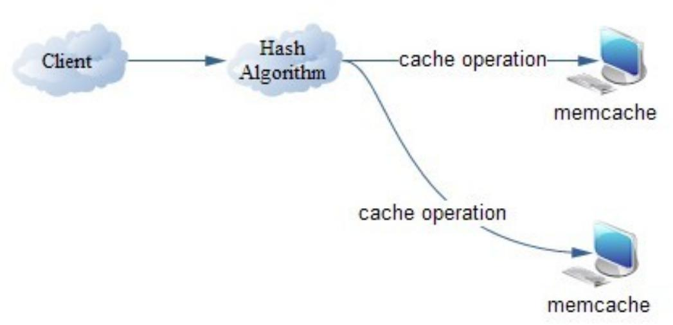
Fig.1
As shown in figure 1, distributed caches, which are very popular at present, are mainly implemented based on memcache [6] . The advantages of memcahche distributed caches are self-customized communication protocol, fast access speed, and supporting a variety of clients. From figure 1, it can be seen that the disadvantages of memcahche distributed caches are (1) the implementation of distribution excessively depends on client and (2) operation involving data adding and deleting is required to be ssynchronously sent to all servers through client. Thus, certain pressure will be caused on client, and also the data of all cache servers will become inconsistent once error occurs in the sending process. In addition, memcache can't implement the persistence of data, and data will be lost completely if a fault occurs to cache server. Thus, the consistency of data can't be ensured.

Architecture Design

Architecture Improvement
To improve the above-mentioned architecture advantages, the following distributed cache architecture is designed in combination with the excellent persistence functions of redis.
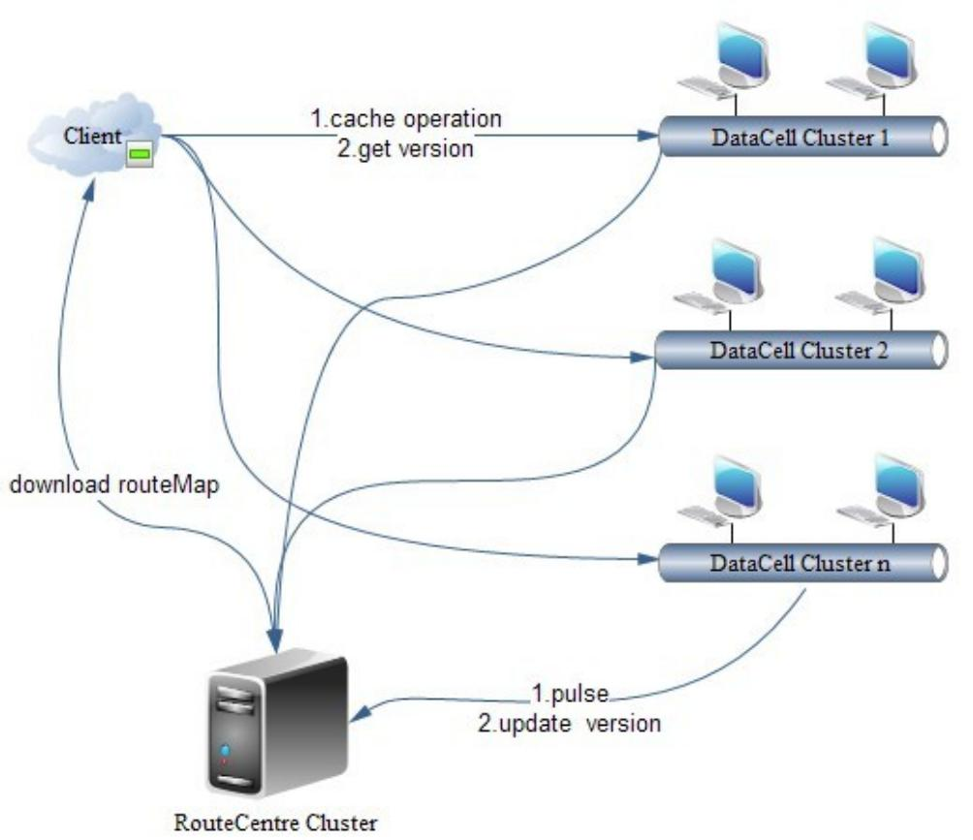
Fig.2
The architecture contains three major roles [4] : Client, RouteCentre and DataCell.
Client acquires an available DataCell routing table from RouteCentre cluster when started up, and then accesses a DataCell corresponding to the cluster according to the routing table initializing connection pool and the hash value of key. If and only if the version acquired from DataCell is higher than the version of client, the latest available DataCell routing table will be re-acquired by client from RouteCentre cluster.
In addition to providing client with a function of downloading routing table, RouteCentre can receive the pulse request from DataCell for re-updating the state of DataCell and updating routing table, and also reporting the latest version back to DataCell.
DataCell provides client with relevant cache operation and current version, and also pulses RouteCentre and update the currently latest version. DataCell is implemented based on Redis, and realizes high robustness and extensibility in combination with the control phasing of RouteCentre.

Data Flow
Frequent access to database needs high consumption or the interfaces of other external resources have variable qualities. For this reason, to pursue faster access speed and higher throughput rate, the system is required to shield the speed difference between the external interfaces at the bottom and also realize the consistency of interface speed [6] . In this demand, request is abstracted into key at Client and access data acquired from corresponding external interface is used as value, and all of them are cached in DataCell, which can be assumed to D1. Through the synchronization mechanism of redis, D2 composing the cluster with D1 will be automatically inserted the key and value, and keep data consistency with D1.
In data validity, if new request and original request are the same (i.e. requested keys are the same), the requests will be forwarded by the hash algorithm in the client randomly to D1 or D2. If one of them has a fault, it can be iintelligently forwarded by client to another fault-free DataCell in the same cluster [5] . Then, the corresponding result of the key will get back to client for call. Thus, in the condition of hitting the target, the interaction with database or external interface can be prevented, and then the speed of accessing the interface can be greatly improved.

Characteristics Implementation
The following characteristics are implemented in the cache system [7] : (1) available enough robustness making the system able to automatically switch to corresponding standbys when single DataCell is down, but not affecting the normal operation of client on cache; (2) DataCell cluster owns enough extensibility, and can rapidly distribute the pressure on the master-system through extending the number of DataCell when performance bottlenecks occur in single DataCell; (3) DataCell possesses good distribution property and can be flexibly deployed in different virtual location or physical virtual, and also automatically registers to RouteCentre through pulse mechanism, and thus cluster is established rapidly and conveniently and a practical foundation is provided for robustness and extensibility.

Performance Analysis
After the distributed cache model based on redis is implemented from prototype, it is compared with the original model based on memcachedb in the same test environment. In the test environment, operating system is Red Hat Linux Enterprise5.5; CPU is four-core 2.5 G; memory is 8G; Redis version 2.02 is used; Redis is used as memory database; Memcache version 2.4 is used; barkley db is used as in-memory database. In a 5-thread environment, reading operation of 10000 times and writing operation of 10000 times are implemented by each thread on test data of 1k, respectively; the total operation time is collected for comparison, and result is shown in the table below.
 | Read(ms) | Write(ms)
Memcachedb | 50360 | 56828
Optimized architecture based on redis | 22570 | 33498
From the above table, it can be seen that the optimized architecture based on redis possesses better performances than memcachedb in both reading and writing, but single reading operation consumes short time than writing operation and is more applicable to the cache requiring less writing and more reading.

Conclusion and Prospect
Through study and improvement on the original cache system in the master-system (i.e. the application of the distributed cache architecture based on redis), not only the speed of accessing the master-system with huge consumption and the external interface with high repeatability is greatly increased, but also high concurrency and stability of cache access are ensured. Therefore, the normal operation of the master-system can continue to be ensured when single-point failure occurs. In addition, the dump way of operation system is used by redis to make data persistent, and bottlenecks will be produced in the condition that data amount is huge and in-memory is small. Therefore, in this aspect, this architecture still owns certain optimization space.
References
[1] Xin Zhu, XiuLei Qin, LianHua Wang. Study on Elastically Distributed Cache Dynamic
Extension [J]. Computer Science and Exploration, 2011, 98-108.
[2] Design and Implementation of Web System Multilevel Distributed Cache Mechanism [J].
Modern library and information technology, 2011, 21-25.
[3] Bingcheng Liu. Deep Discussion on the Application of Ehcache System in Integration
Environment [EB/OL]. 2010. www.ibm.com.
[4] Chen Dan, Lin Zhao. TAOBAO Database Structure Evolution Course [EB/OL]. 2010,
www.slideshare.net/zhaolinjnu.
[5] Wenxiao Li, XiaoHu Yang. Message Oriented Middleware Storage Model Based on Distributed
Cache [J]. Computer Engineering, 2010, 93-95.
[6] Chiu D, Agrawal G. Flexible Caches for Derived Scientific Data over Cloud Environments
[R].The Ohio State University, 2009.
[7] Jure P. Using Memcache for Data Distribution in Industrial Environment [C]. Proc. of the 3rd
International Conference on Systems, 2008, 368-372.

